Mix and Match: PLATE MOVEMENT http://www.learner.org/interactives/dynamicearth/plate.html p283 of text

1. Divergent Boundary/Ocean Ridge | 2. Convergent Boundaries | 3. Transform Boundaries

Use a colour or number scheme match the information below with the types of boundaries that exist between tectonic plates. For each heading you need to find: a definition (thick black line), 3 diagrams/pictures, consequences (thin black line) and an example (dotted line). ALL boxes below should be used.

Magma from the mantle rises:
- Forms underwater volcanoes
- Creates new oceanic crust (the magma is cooled and solidified by sea water)
- Sea floor spreads
Plate boundary where the plates are pushed together
Boundary between the Eurasian plate and the Indian plate at the Himalayas
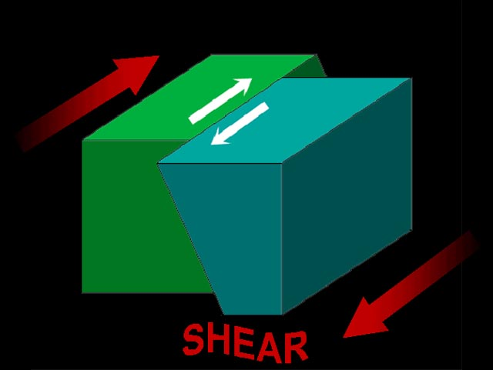
When oceanic crust pushes against continental crust subduction occurs
- Oceanic crust sinks below the continental crust
- Causes powerful earthquakes
- Creates explosive volcanoes when the oceanic crust melts & cold sea water meets hot magma
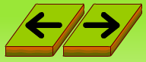
Plate boundary where the plates are moving apart

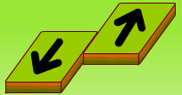
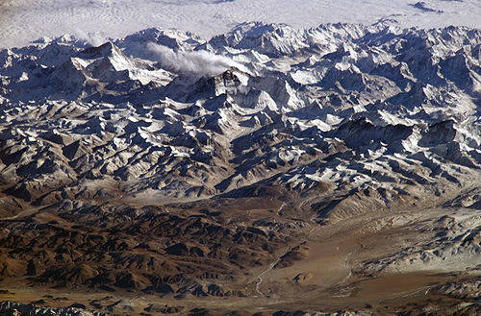
Plate boundary where two plates slide past each other
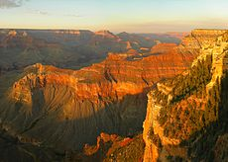
Boundary between the Pacific and Antarctic plates
When two continents on colliding plates push against each other continental crust crumples upwards (folding):
- Creates mountain ranges
- E.g. Himalayas
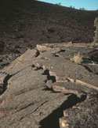
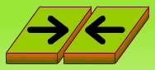
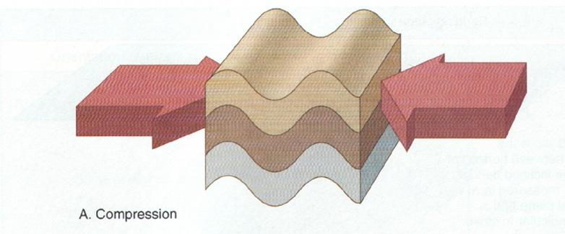
Boundary between the Pacific plate and the Indo-Australian plate, crossing New Zealand

Boundary between the Pacific plate and the North American Plate in California (San Andreas Fault)
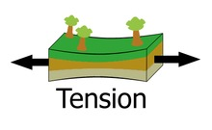
Earthquakes
- If the sliding is smooth there can be small earthquakes or tremors
- If something prevents the plates from sliding pressure builds up until there is enough force to restart sliding with a jolt – this causes a larger earthquake

